A Framework of Questions for Jobs-to-be-Done Interviews

JTBD interview questions for the Outcome-driven Innovation method for building discussion guides to build a qualitative data model for a job

**Created By:** Mike Boysen and sourced from the pioneers

[Download the combined works](https://jtbd.one/jtbd-interview-pdf) on this topic in PDF form. It includes “Getting Results from Jobs-to-be-Done Interviews” as well as these cheat sheet

<https://jtbd.one/jtbd-interview-pdf>

# Opening Comment

Don’t worry about fancy, specialized tools. Open a Google Doc and use a numbered list to create your job map. That’s what I do. You’re probably going to change it as you think about it and collaborate with others, so make it easy on yourself. Just do it!

Same holds true for outcomes. There is no reason you need a fancy tool or database. Use the same Google Doc.

If you need a visual map, insert an inline Google Drawing; but don’t waste your time until you’ve finalized your map.

# Structure of the “Job Statement”

In order to promote consistency, and a stable view of the market, a universal standard has been developed for describing a **job-to-be-done**. Using this standard, we’ll use the following example of a job statement throughout the document to make it more readable, and hopefully more understandable.



I selected a core job which also has a *context*. You don’t have to do this. However, I considered the fact that a music enthusiast who wants to listen to music while out for a run has complexities that other contexts don’t. This means there is a likelihood that further hidden segmentation centered-on unmet needs can be discovered through quantitative analysis.

*Common verbs associated with jobs are:*

|  |  |  |  |
| --- | --- | --- | --- |
| Achieve | Allow | Confirm | Coordinate |
| Correct | Create | Demonstrate | Detect |
| Determine | Develop | Discover | Ensure |
| Experience | Find | Fix | Get |
| Help | Identify | Improve | Keep |
| Learn | Locate | Maintain | Make |
| Obtain | Plan | Prepare | Prevent |
| Protect | Provide | Relieve | Remember |
| Remove | Share | Stay | Stop |
| Teach | Understand | Update | Verify |

## Discover the job executor

Before you begin looking for jobs, you need to narrow your focus to a **single job executor** (think of this as the end user.) In this case, a “music enthusiast.” It could just as easily be an orthopedic surgeon.

**UPDATE:** In fact, you can start with the job and may find that there are many ways to describe the job executor. Electricians cut wood in a straight line, as do carpenters, roofers, plumbers, etc. These are all different *trades*, and therefore we name the job executor *Tradesmen*. When getting breakfast on the go, we can generally describe this group as *Commuters*, when studying people who are commuting to work in the morning.

## Discover the job

Once we know that we’ll be studying music enthusiasts, we can begin by identifying the job they are trying to get done. We can hypothesize that they want to **listen to music**. But, that could be somewhat broad. By asking more questions we can begin to understand some of the contexts in which they listen to music. We can start by asking them a question:

* What products and services do you currently use to “**Listen to music while out for a run”**? [list the solutions]
  1. Solution 1
  2. Solution 2
  3. Solution 3
  4. ...
  5. Solution n

We can list these solutions to help us build our base of information

### Discover why each solution is hired

If we follow up and ask a few more questions we might learn that some music enthusiasts hook a smartphone into their vehicle’s audio system to get more options, while others may tell you they need something they can take with them while out on a run.

* What are you trying to accomplish by using each product/service?
* What goals or objectives does each product/service help you to accomplish?
* What problems does each product/service help you to prevent or resolve?
* **When** do you select one solution over another?

For the remainder of this study, we will use a context…

“Music enthusiasts who want to listen to music **while out on a run**”

I thought carefully about this and asked if there were circumstances that might occur while *out for a run* that could drive further segmentation (described later). If I hadn’t come to that conclusion, I would probably have left out the context and used a broader set of outcomes.

**Note:** In the case where no product yet exists, the core job should be used without a context. It’s most likely that segments describing a circumstance will best be uncovered through a quantitative analysis of unmet needs, using the model you are about to build.

### Discover why each product/service might be hired

* What would the ideal product/service help you to accomplish when **out for a run?**
* What else are you trying to accomplish before, during, or after using the current product/service you use?
* What other responsibilities do you have before, during, or after using the current product/service you use?
* What other products/services would you like to be offered before, during, or after using the current products/services you use?
* What would each allow you to accomplish?

### Discover other jobs of customers

* What are you trying to accomplish when **listening to music while out for a run?**
* What tasks and/or activities?
* As it relates to **listening to music while out for a run**, what are your goals and objectives?
* As it relates to **listening to music while out for a run**, what problems are you trying to prevent or resolve?
* As it relates to **listening to music while out for a run**, what are you trying to determine or decide?

### Discover experience jobs of customers

Experience “jobs” are important to consider in the world of service innovation, where many times people are trying to get more than simply a functional job done; they want to have an experience **while doing so**. We can all think of many such examples. This should not be confused with *customer experience*. Customer experience must take into account functional and emotional jobs, and the related needs. The experience of *consumption* simply is not enough when striving to achieve the perfect *customer* experience. Therefore, we view these as they relate to functional jobs first.

* What experiences are you seeking when **listening to music while out for a run**?
* What are you trying to experience, discover, appreciate, and so on, by using product/service that help you to **listen to music while out for a run**?
* What would the ideal solution help you to experience, discover, appreciate, and so on?

**Note:** Experience jobs are not mapped; they are stated. You can then score them for importance and satisfaction as you would outcomes on the core job.

*Common verbs associated with experience jobs are:*

|  |  |  |  |
| --- | --- | --- | --- |
| Experience | Discover | Appreciate | Learn |
| Inspire | Escape | Enjoy | Be or Become |
| Achieve | Support | Share | Remember |
| Forget |  |  |  |

### Discover emotional jobs

These are similar to “be goals” in that they are feelings or perceptions that result from getting the core functional job done successfully. You want to avoid framing your investigation purely around emotion, since there is no discrete path to the solution space.

* If you had the ideal solution for **listening to music while out for a run**, how would that make you feel, or how would you be perceived?
* What feelings or perceptions would be avoided?

A common break-down might be grouped like this:

* I want to feel…
* I want to avoid feeling…
* I want to be perceived as…
* I want to avoid being perceived as...

### Discover new and emerging jobs

* What new jobs will you need to accomplish as a result of a particular discovery, legal or regulatory change, or technology development?

### Consumption Jobs

While capturing jobs, it may be useful to understand relevant consumption jobs. Not all will be relevant to a core job. There is also a difference between **product** consumption chain jobs and **service** consumption chain jobs.

|  |  |  |  |
| --- | --- | --- | --- |
| Product consumption jobs | | Service consumption jobs | |
| Purchase | Receive | Assess needs | Evaluate options |
| Install | Setup | Select service | Acquire service |
| Learn to use | Interface with | Initiate delivery | Receive service |
| Transport | Clean | Monitor delivery | Resolve problems |
| Store | Maintain | Adjust service |  |
| Upgrade | Repair |  |  |
| Dispose |  |  |  |

# 

# Discover the job map

One of the main purposes of JTBD interviews is to decompose the job into logical steps. These steps are not activities or procedures; they are things that must be accomplished along the way to getting the job done. There are simple tests below to help you to exclude any hint of solutions. Since we are focusing on the core job-to-be-done, we want this map to be stable over time.

We’ll use the example job of “**Listen to Music while out for a run**” throughout.

## Validate the Job Steps with each Question

**Example:** Listen to music *while out for a run*

* **Valid step:** gather the desired music
* **Invalid step:** Download MP3 files **[solution]**

Does the step apply universally for any customer executing the job, or does it depend on how a particular customer does the job?

* **Valid step:** Order the music for listening
* **Invalid step:** Click the column header in Amazon’s recently added files **[solution]**

## Define the Execution Step

The execution step describes the job as we normally think about it. In this case**,** running isn’t the job to be done, listening to music at some point during the run is the job. We separate this out because music enthusiasts who listen to music while out on a run will have specific needs *while listening to music*.

* What are the most central tasks that must be accomplished when **listening to music while out for a run**?

## Define Pre-execution Steps

Prior to listening to music while out on a run, there are things that must be accomplished. These could be done prior to beginning the run, or perhaps while running. We break these out into discrete steps so we can put *needs* into the appropriate context.

* What needs to be happen before **listening to music while out for a run** can be successfully carried out?
* What needs to be defined or planned before **listening to music while out for a run**?
* What needs to be located or gathered before **listening to music while out for a run**?
* What needs to be prepared or set up before **listening to music while out for a run**?
* What needs to be confirmed before **listening to music while out for a run**?

## Define Post-execution Steps

There are other steps that are distinct from listening. For example, we may be monitoring whether the correct music is playing, or perhaps if the audio quality of the music is sufficient. We may also need to monitor the volume of the music.

These indicators could lead a runner who is listening to music to make adjustments - change the song, increase the volume, etc. - to ensure they achieve the desired listening experience. We don’t all have the same needs, nor do we *listen to music while out on a run* in the same circumstances (e.g., high winds vs. calm, rain vs. sunny, etc.). But we’re all still listening to music, while out for a run.

* What must happen after **listening to music while out for a run** to determine that **listening to music while out for a run** is successfully carried out?
* What must be monitored or verified after **listening to music while out for a run** to ensure that **listening to music while out for a run** is successfully performed?
* What must be modified or adjusted after **listening to music while out for a run**?
* What must be done to properly conclude **listening to music while out for a run** or prepare for the next time you **listen to music while out for a run**?

## Alternate Questions

* [Define, Plan, Select, Determine] What needs to be defined or planned up front to ensure success in **listening to music while out for a run**?
* [Located, Gather, Access, Retrieve] What inputs or resources need to be located to ensure success in **listening to music while out for a run**?
* [Prepare, Set up, Organize, Examine] What needs to be prepared to ensure success in **listening to music while out for a run**?
* [Confirm, Validate, Prioritize, Decide] What needs to be confirmed before **listening to music while out for a run**?
* [Execute, Perform, Transact, Administer] What must a **music enthusiast** do to execute the core purpose of **listening to music while out for a run** successfully?
* [Monitor, Verify, Track, Check] What must be monitored to ensure that **listening to music while out for a run**  gets done successfully?
* [Resolve, Troubleshoot, Restore, Fix] What problems related to **listening to music while out for a run** done must be resolved on occasion?
* [Modify, Upgrade, Adjust, Maintain] What modifications are necessary to ensure success in **listening to music while out for a run**?
* [Conclude, Store, Finish, Close] What must **music enthusiasts** do to successfully conclude **listening to music while out for a run**?

# 

# Discover the desired outcomes

Also known as *customer performance metrics* or *customer needs,* these are the statements we collect from Jobs-to-be-done interviews using the Outcome-driven InnovationⓇ framework.They are not the same as *pain points*. They are **metrics** (stable over time) which can have a number of *states* depending on *who* is responding, *when* they are responding (with the current solution they are using), and what circumstance they may find themselves in*:*

* ...**underserved** (very important and very unsatisfied)
* ...**overserved** (very unimportant and very satisfied)
* ...**irrelevant** (very unimportant and very unsatisfied)
* ...**appropriately served** (somewhat important and somewhat satisfied)
* ...**table stakes** (very important and very satisfied)



It’s important to remember that we are capturing a comprehensively exhaustive, mutually exclusive, and stable set of desired outcome statements across the entire job map. You might find 50-150 of these for a core job to be done. **In this state, they are unquantified and simply *describe* what perfect execution of the core job would look like**.

## Translate what you hear to “desired outcome statements”

As you ask your questions...

**You hear….**

“I wish I it were easier to find songs that fit my mood”

**You translate this to…**

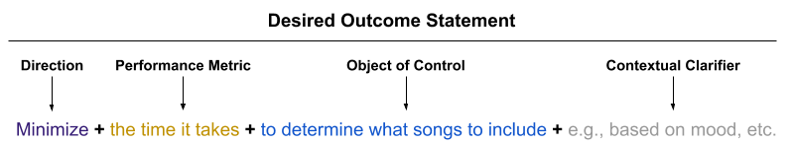

## Ask the following questions for each step in the Job Map

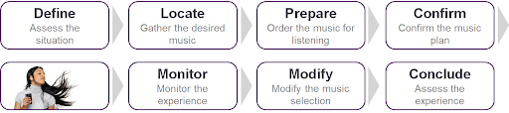

We’re trying to do two things: First, eliminate time required in getting the job step done, and second, eliminate variability and waste from the job step. None of these questions lead to a discussion about a product. You’re simply discussing the steps in a **core** job.

* What do you do first when **gathering the desired music**? What do you do next?
* What makes **gathering the desired music** time-consuming or slow? What makes it cumbersome or inconvenient?
* What makes **gathering the desired music** problematic or challenging? What causes it to be inconsistent or to go off track?
* What makes **gathering the desired music** unpredictable?
* What makes **gathering the desired music** wasteful?
* What makes **gathering the desired music** inefficient?
* What makes **gathering the desired music** ineffective or the output of poor quality? What would the ideal result look like?
* What solutions (products, services, etc.) do you use in this process step? What makes [SOLUTION] better than [ANOTHER SOLUTION] in this process step? What makes [SOLUTION] worse than [ANOTHER SOLUTION] in this process step?

### Other probes…

* If you don’t plan the job well, what could go wrong?
* If you don’t do [a step] well, what could go wrong?
* Is there any circumstance or situation that could cause you not to perform a step? Or perform it well? What is that? [Complexity]
* Over time, what changes have you made to the way you get the step done, and why?
* What improvements/changes have you made to get the job done faster?
  + What do you avoid now that you didn’t or couldn’t avoid in the past when getting the job done?
* Tell me about your worst experience when trying to get the job done, what went wrong?
* What changes have you made to avoid problems you’ve faced in the past?
* Are there times when you use different solutions to get the job done? Why is that?
* What could go wrong if you don’t keep track of the success of the job or step?
* Are there times where something went off-track, and you weren’t able to recover, why not? How about times when you did recover, how did you do that?
* What things do you do after a job to make sure you’re more successful, or have a better experience the next time you try to get the job done?

### Some Desired Outcome Best Practices

1. When satisfying an outcome that “minimizes the time it takes to…” then it’s unnecessary to develop an outcome that avoids a related problem
2. **Time** and **Likelihood** are the only two units of measure used on core jobs
   1. This is based on years of testing in surveys and avoids overloading respondents in long surveys with continually changing measures.
   2. Measures like “number” or “amount” or “frequency” are more closely related to consumption jobs, which are solution-specific
3. Minimize the use of double negatives when “minimizing the likelihood of/that…”
4. “Increase” is no longer used after extensive testing.
   1. There are no upper bounds to increase. Minimize is bounded to zero.
5. “Minimize the likelihood” is problem avoidance
   1. Avoiding waste
   2. Avoiding errors
   3. See Lean’s [7 Deadly Wastes](http://leanmanufacturingtools.org/77/the-seven-wastes-7-mudas/)
6. Desired outcomes in a Job Map **must be MECE**
   1. Mutually exclusive
   2. Collectively exhaustive
   3. *Example*: If you satisfy an outcome that minimizes the time...make sure another outcome with minimize the likelihood isn’t also satisfied before including it
7. Do not use **adjectives**or **adverbs** in your outcome statements (or your jobs statements!)
8. Do not forget to provide examples (e.g.), especially when there is a word in the outcome statement that could be interpreted differently by different people.
9. However, the perfect outcome does not need examples because it is self-explanatory and not subject to interpretation
10. Use “minimize the likelihood of getting something wrong” and not “minimize the risk of getting something wrong”
11. A desired outcome **must be measurable and controllable** in the design of the system
    1. Job executors must be able to control the outcome through action or solution selection
12. Desired outcomes from one step should feed the outcomes from subsequent steps; where practicable
13. Do not include outcomes which would force a selection of another solution just for that step.
    1. The goal of the solution should be to get more of the job done on one platform, not multiple platforms
14. If any particular step begins to accumulate more than 10 outcomes, it’s time to consider breaking the step into two steps
    1. The exception could be a single execute step, where we tend to see the most outcomes
    2. Conversely, if you can only pull out 2-3 outcomes, you might consider whether the step can be folded into another (which would likely require a step name change)
15. If you have a step that crafts outcomes for performance evaluation, you should have a monitoring step that evaluates performance using outcomes that measure those same criteria
    1. But, just because you have evaluation metrics doesn’t mean you need to have a step that develops those measures…it depends on the job

## The Market

## 

## The Solutions Over Time

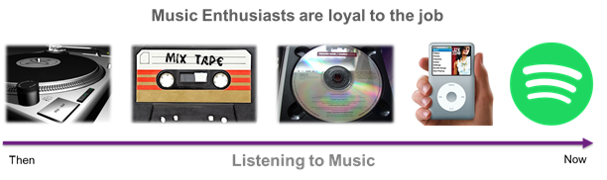

## Finding complexity & circumstance

In order to understand why one group might have different unmet needs than others, it’s important to find circumstances where the step (or job) didn’t go as planned. Have the person you interview think of a time when they struggled more than normal. Ask them what lessons they’ve learned over the years, and what they avoided by adapting their approach.

These **complexity factors** are extremely important when analyzing the hidden market segments that emerge when the metrics are prioritized and grouped around shared and distinct sets of unmet needs.

* Think of a time when **gathering the desired music** didn’t turn out as planned? Why do you think that was?
  + What was different about this time than other times?
  + Did you do something differently? Did you do it prior to entering the context (out for a run)?
  + Did something around you have an impact?
  + Have you changed the solution/method you use? How and why did that help?
* What have you done over time to **gather the desired music** more quickly? Why did you feel you had to do it? How did that help?
* How have you changed the way you **gather the desired music** to avoid problems you’ve experienced in the past? What were those problems?

Complexity factors should be **described in terms of a range**. For example:

1. Wind condition (low vs. high)
2. Precipitation (low vs. high)
3. Etc.

A,

*These will be hugely important after segmenting the market around unmet needs because you won’t be able to do so with demographics, firmographics or psychographics.*

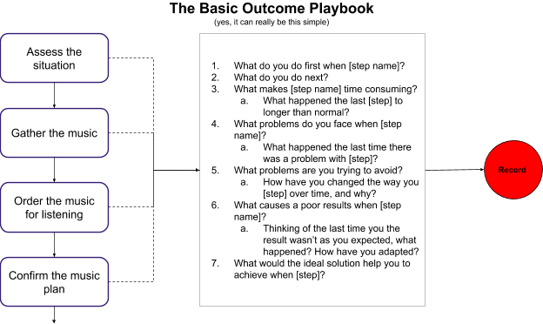

# 

# Dynamically building questions (optional)

A method from the lean world for creating dynamic and unique question combinations (before, or during interviews)

While using a job map and a standard set of questions will generally generate good results in identifying outcomes for a job-to-be-done, it is often helpful to craft unique sets of questions in order to attack the problem from different angles, or add dimensions that make the respondent think more carefully, or stimulate their thoughts as questions get boring and repetitive. We should always be looking for different ways to trigger a thought as we perform our jobs-to-be-done interviews.

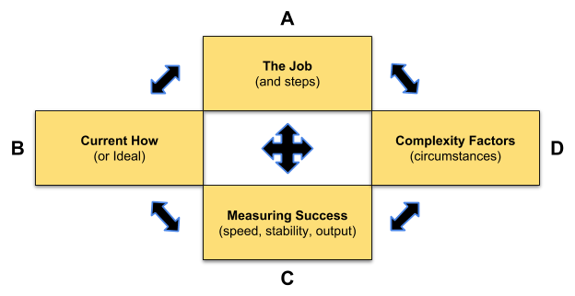

This is a basic framework with four pillars. There are 14 possible combinations of these pillars in constructing questions. In conjunction with job steps, current solutions, and uncovered circumstances, this can generate hundreds of different ways to elicit information from those being interviewed for jobs-to-be-done.

You can use this to aid in the development of a discussion guide, and you can also use it to construct questions on the fly as the conversation unfolds.



## Build a Table of Statements to construct JTBD interview questions on the fly

Create a simple worksheet or discussion guide that allows you to organize the category information you are collection to use as inputs to further question framing, or to use later to document solutions and complexity factors.



## A dynamic list of potential questions

The following table offers some basic examples on how you can pair the pillars to generate questions for your discussion guide and/or come up with questions on the fly.

|  |  |  |
| --- | --- | --- |
| **#** | **Combination** | **Examples** |
| 1 | A | * What are you trying to accomplish when **gathering the desired music** |
| 2 | AB | * Can you walk me through how you currently **gather the desired music** when using **Pandora**? |
| 3 | AC | * Explain the connection between **gathering the desired music** and how you measure success. Could it be faster? More reliable? |
| 4 | AD | * Think of a time when you struggled to **gather the desired music** in the past? What was different about that time compared to others? |
| 5 | ABC | * When you’re **gathering the desired music** on the ***Amazon Music Player*,** how do you know when your successful? How could the ideal solution help you be more successful? |
| 6 | ABD | * How would the***ideal solution*** help you **gather the desired music** when you’re **out for a run** **out for a run *in the rain/wind***? Why? |
| 7 | ADC | * When **gathering the desired music,** what problems would you like to avoid **when it’s raining**? |
| 8 | ABCD | * What adjustments have you made in the past when **gathering the desired music** in a way that avoids the problems you experienced ***when it was raining/windy/sweating/noisy/bouncing***? |
| 9 | B | * Can you walk me through how you **gather the desired music** today? |
| 10 | BC | * When you’re ***using your iPhone***, what slows you down? Why is that a problem? * When you’re ***using Pandora***, what kind of problems do you run into? Why are they important to resolve? |
| 11 | BD | * How does **your iPhone** help you to avoid problems when out for a ***run in the rain/in the wind/and it’s noisy/and you’re bouncing***? |
| 12 | BCD | * When you’re **using your iPhone**, how well does it help you get things done faster when **you’re out for a run in the rain**? |
| 13 | C | * Is it generally important for you to get tasks done quickly? * Do you have any common, or not so common, problems that you like to avoid? |
| 14 | CD | * Are there times when the situation you’re in makes it harder to get things done quickly than at other times? How does that impact you? * Are there times when the situation you’re faced with makes it hard to avoid certain problems? |

# 

# The Ultimate Objective

Our objective is to build a qualitative data model that describes the job (and related jobs) in such a way that we know both its purpose, and how job executors measure success. Without showing a completed model, Strategyn’s Jobs-to-be-Done “Needs Framework” describes all of the different types of information and their relationships.

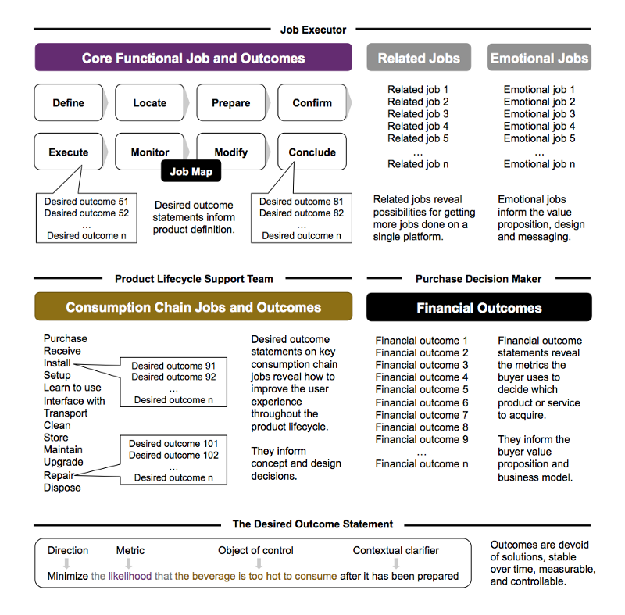

To help you get there, we’ve developed this [Jobs-to-be-Done Canvas](https://jobs-to-be-done.com/the-jobs-to-be-done-canvas-f3f784ad6270) as a starting point to help get your hypotheses down on paper (like to Medium article above). Expect an adapted interview guide for the canvas, and examples of use. More than likely, this entire interview guide will be reworked to support that step-by-step of the Jobs to be Done Canvas. Hopefully that’ll make it easier.

Give me a bit of time on this 😉

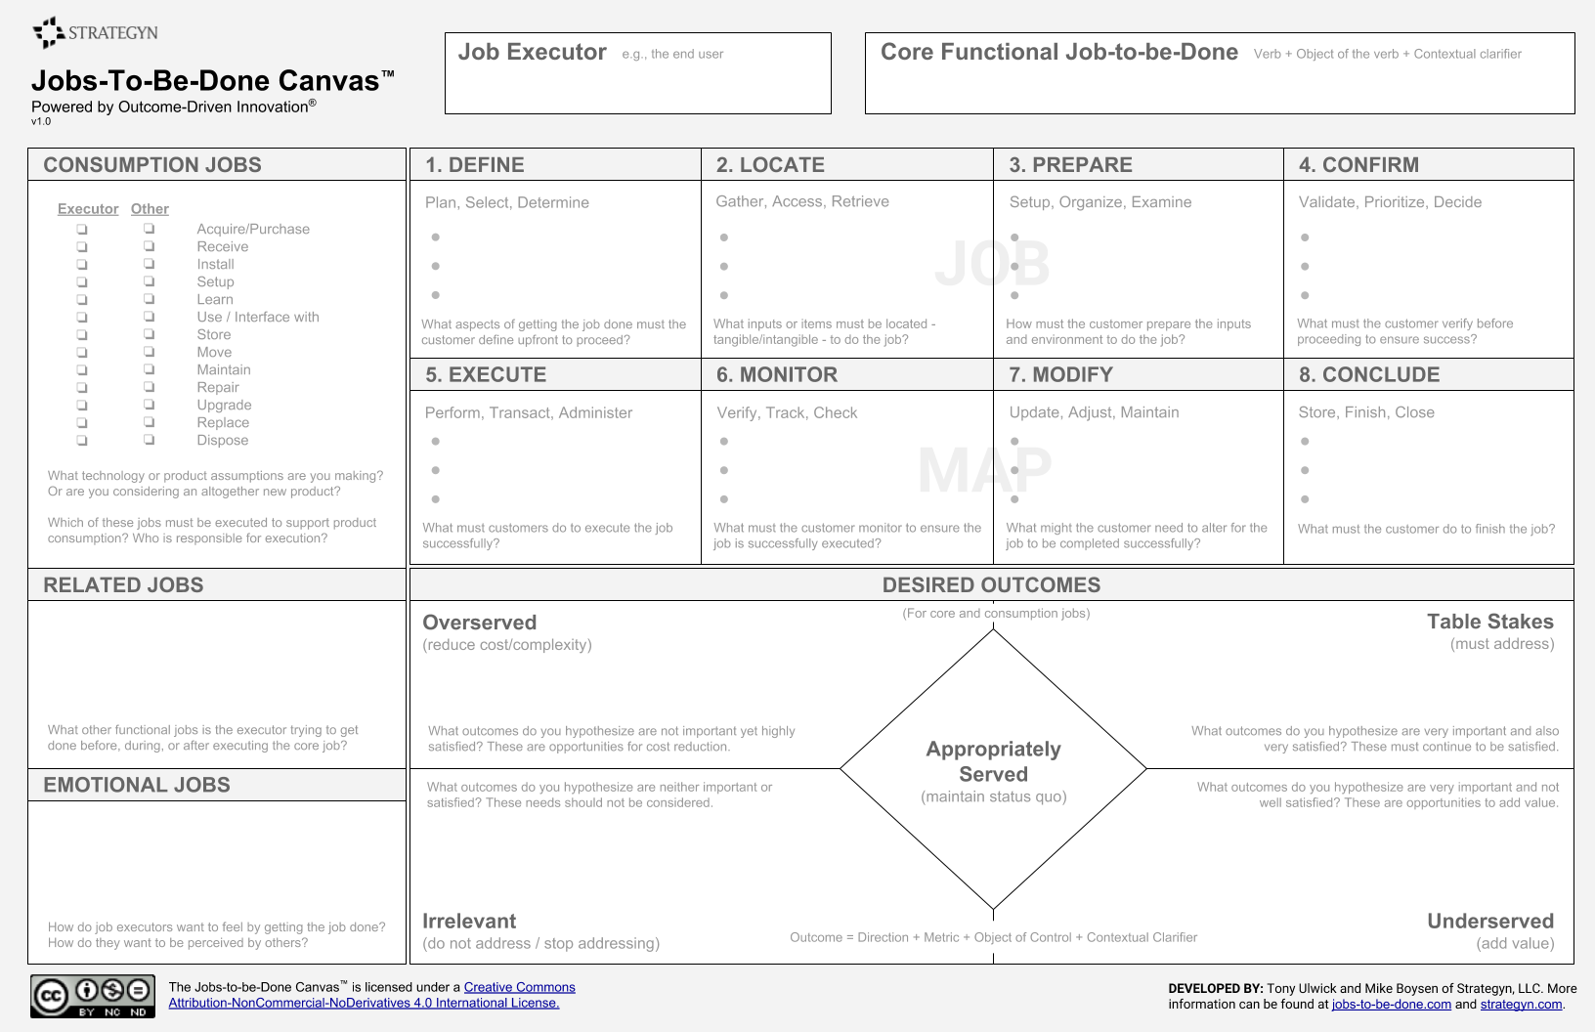

# Universal Maps (and examples)

One of the most powerful tools used in jobs to be done interviews is the Universal Job Map. It’s a great strawman to begin your conversations with job executors. Any one of the steps could be broken down into multiple steps, depending on what you’re hearing in your interviews.

### Universal Job Map (for Products)

For product innovation, the universal job map has 8 stages (the 9th is aligned to services). Following this map provides simplicity, and consistency to the qualitative interviewing process.

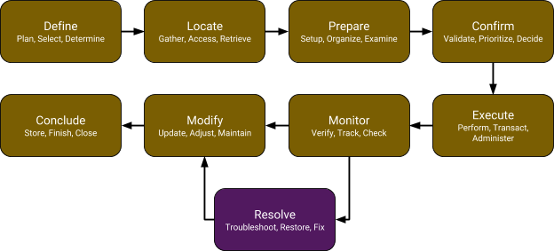

### 

### Universal Job Map (Obtain a Service)

Services are a bit different. This is a universal map for **obtaining a service** and highlights all of the things that are typically considered by those that hire services.

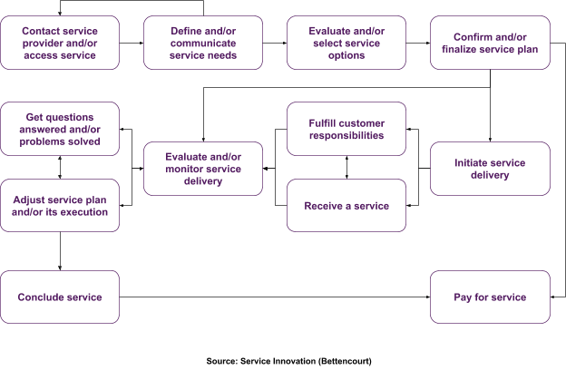

### 

### Example: Obtain Product Support

This is a specific example showing how the universal map for obtaining a service turns into a job map for obtaining product support (which is a service).

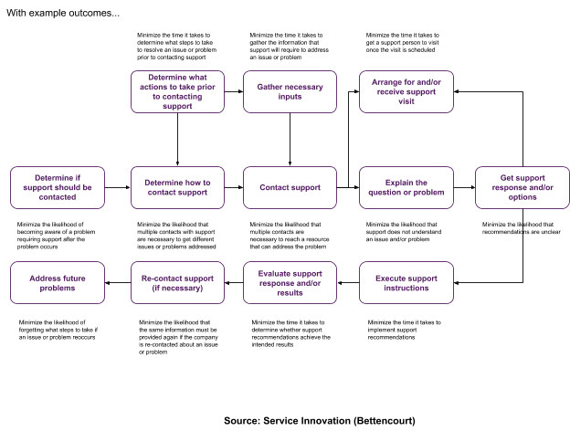

### 

### Universal Job Map (Provide a Service)

On the other side of the coin, a provider has the job of providing a service. Since the goal of the provider should be to provide an exceptional customer experience, this job should line up closely with the customer’s job of obtaining the service. However, the job executors for the provider will also have needs when they try to accomplish that goal.

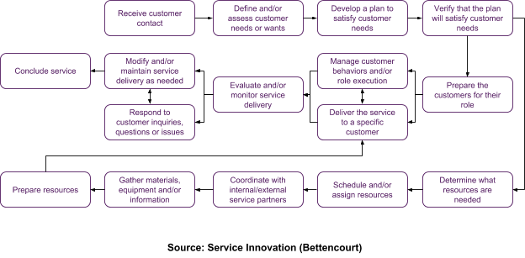

# 

# Sources

The original inspiration for this guide comes from the popular [**Job Mapping Guidelines**](https://docs.google.com/presentation/d/1MffXUkvsJlXV1TWjkOTiLUVmrVmbQr62_kSkSq2yWC8/edit?pli=1#slide=id.g1a214c3c75_0_58) deck I’ve been sharing for a few years. The rest of it comes from the **true pioneers of Jobs-to-be-Done** (*see below*). I’ll also add my colleague Eric Eskey for showing me a better format this and also some better questions. And then there is the late Peter Scholtes, who wrote one of my favorite books of all time.

1. Bettencourt, Lance (2010-05-15). Service Innovation: How to Go from Customer Needs to Breakthrough Services (Kindle Locations 686-818). McGraw-Hill. Kindle Edition.
2. Lance A. Bettencourt and Anthony W. Ulwick, “The Customer-Centered Innovation Map,” Harvard Business Review 86, no. 5 (May 2008): 109-114.
3. Ulwick, Anthony (2005-09-06). What Customers Want: Using Outcome-Driven Innovation to Create Breakthrough Products and Services. McGraw-Hill Education. Kindle Edition.
4. Ulwick, Anthony (2016-10-28). JOBS TO BE DONE: Theory to Practice. Idea Bite Press. Kindle Edition. [**Click here to download PDF for FREE**](http://jtbd.one/jtbd-book)
5. Scholtes, Peter R. (1998) The Leader’s Handbook. McGraw-Hill